**ANGLES**

**Pearson Edexcel - Thursday 4 June 2020 - Paper 2 (Calculator) Foundation Tier**

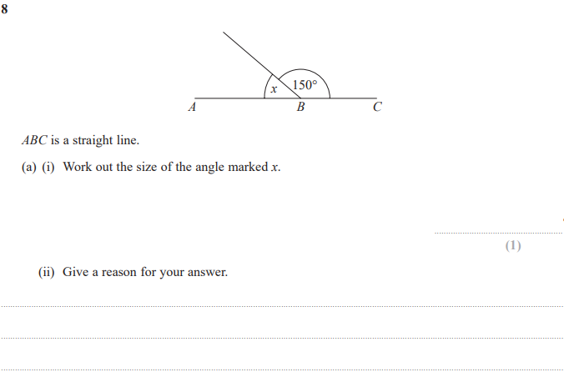

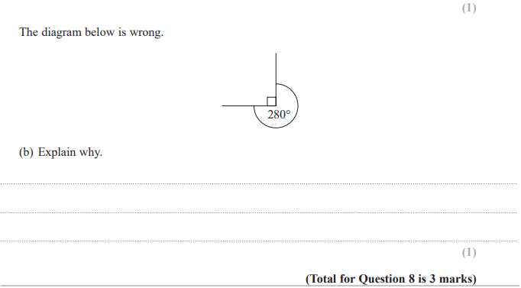

**Pearson Edexcel - Tuesday 11 June 2019 - Paper 3 (Calculator) Foundation Tier**

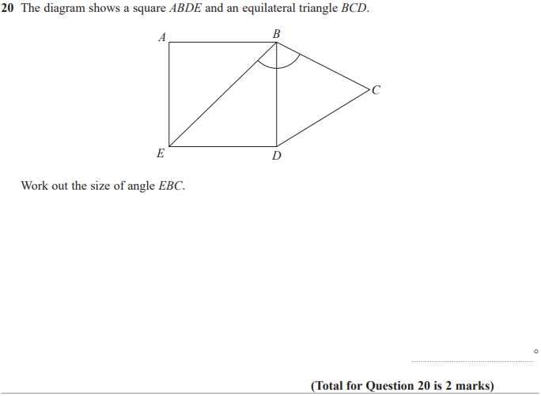

**Pearson Edexcel – Specimen 2 - Paper 2 (Calculator) Foundation Tier**

**Pearson Edexcel – Specimen 1 - Paper 1 (Non-Calculator) Foundation Tier**

**Pearson Edexcel – Specimen 1 - Paper 2 (Calculator) Foundation Tier**

**Pearson Edexcel – Specimen 1 - Paper 3 (Calculator) Foundation Tier**

**Pearson Edexcel – Sample Paper 1 (Non-Calculator) Foundation Tier**

1. Diagram

   Description automatically generated

**OCR – Tuesday 03 November 2020- Morning - Paper 1 (Calculator) Foundation Tier**

1. Table

   Description automatically generated

**OCR Thursday 07 November 2019- Morning (Non-Calculator) Foundation Tier**

1. Diagram

   Description automatically generated

**OCR Monday 11 November 2019 – Afternoon (Calculator) Foundation Tier**

1. Diagram

   Description automatically generated

**OCR Thursday 6 June 2019 – Morning (Non-Calculator) Foundation Tier**

1. Diagram

   Description automatically generated

**OCR Tuesday 11 June 2019 – Morning (Calculator) Foundation Tier**

1. Diagram

   Description automatically generated

**Pearson Edexcel –Sample Papers - Paper 2 (Calculator) Foundation Tier**

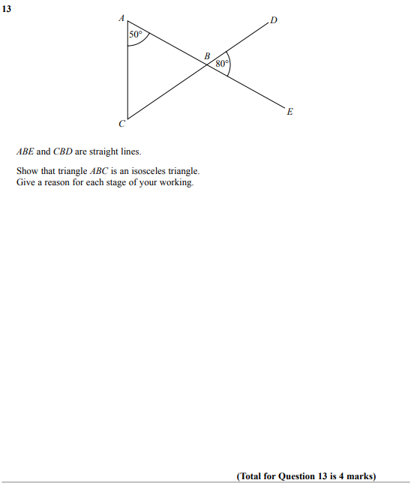

**Pearson Edexcel – Sample Papers - Paper 3 (Calculator) Foundation Tier**

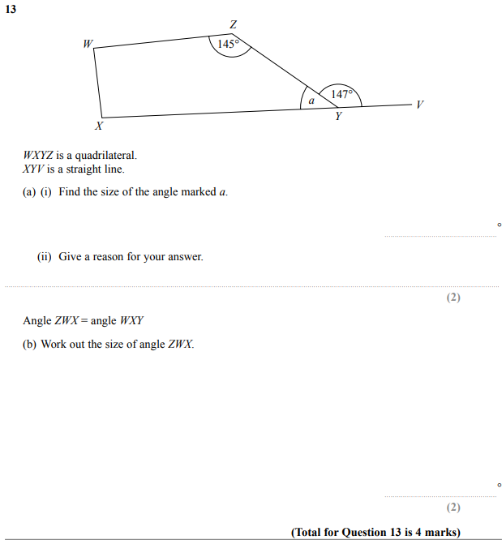

**OCR Thursday 25 May 2017 – Morning (Calculator) Foundation Tier**

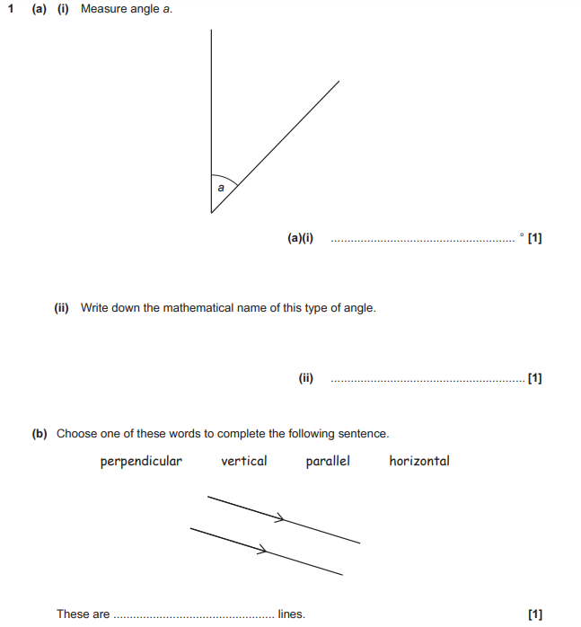

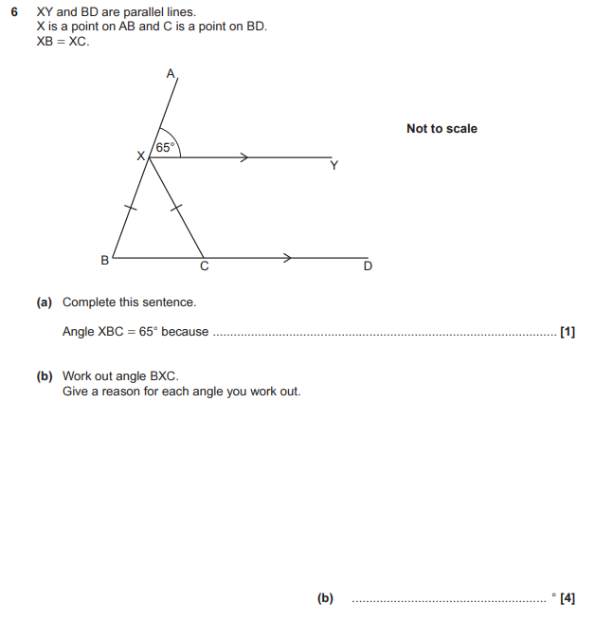

**OCR Thursday 8 June 2017 – Morning (Non - Calculator) Foundation Tier**



**OCR Sample Question Paper 1 – Morning/Afternoon (Calculator) Foundation Tier**

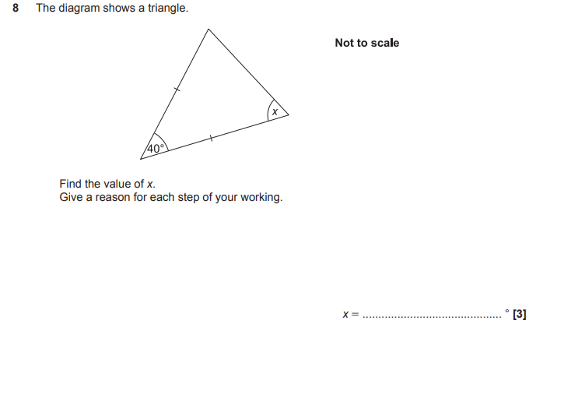

**AQA Thursday 4 June 2020 – Morning (Calculator) Foundation Tier**

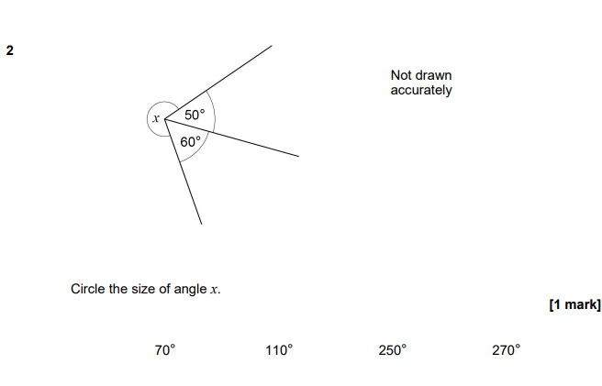

**AQA Monday 8 June 2020 – Morning (Calculator) Foundation Tier**

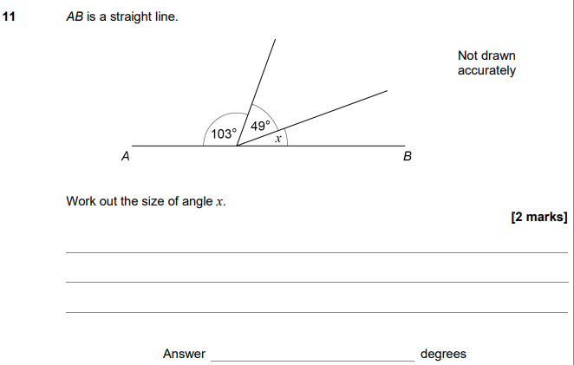

**AQA Tuesday 21 May 2019 – Morning (Non-Calculator) Foundation Tier**

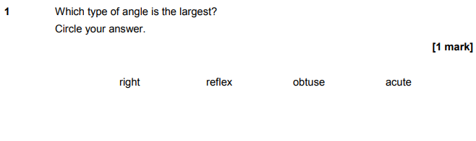

**AQA Thursday 11 June 2019 – Morning (Calculator) Foundation Tier**

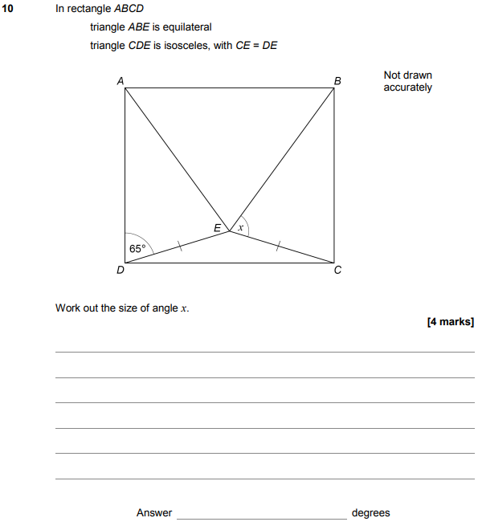

**AQA Thursday 7 June 2018 – Morning (Calculator) Foundation Tier**

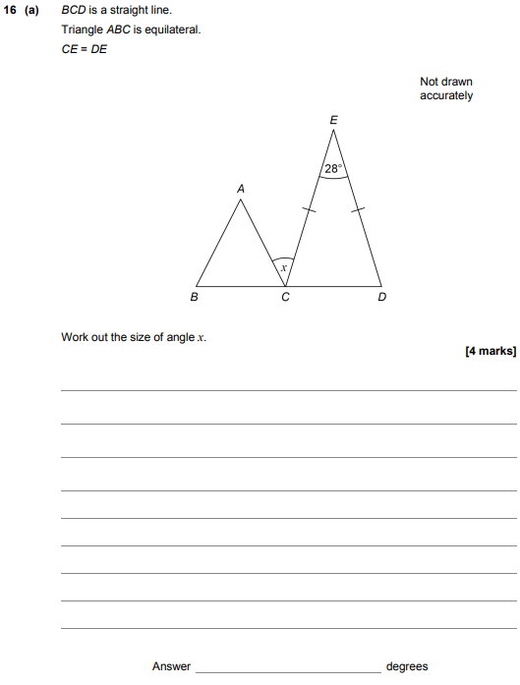

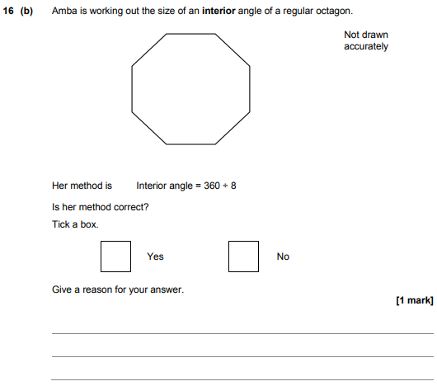

**AQA Thursday 8 June 2017– Morning (Calculator) Foundation Tier**

